Advancing Robotic Agility and Efficiency: Architectural
Innovations in the AGILEHAND Project
Giovanni Mazzuto¹, Filippo Emanuele Ciarapica¹, Jan Hendrik Hellmich², Laura Moya-Ruiz³ and Francisco Fraile Gil³
¹ Dipartimento Ingegneria Industriale e Scienze Matematiche, Università Politecnica delle Marche, via brecce bianche, Ancona, 60131, Italy
² Department of Production Quality and Metrology, Fraunhofer Institute for Production Technology IPT, Aachen, 52074, Germany
³ Centro de investigación en Gestión e Ingeniería de Producción, Universitat Politècnica de València, Camino de Vera, Valencia, 46022, Spain
Abstract
This paper delves into the AGILEHAND project, an initiative funded by the European Union's Horizon Europe program, that aims to advance robotic capabilities for manufacturing soft and deformable objects such as food, clothing, and plastic items exploring the structured architecture of digital solutions, highlighting its necessity for successful project outcomes. Central to this project is the development of innovative technologies focused on grading, handling, and packaging these items, thus improving the efficiency and adaptability of European manufacturing and logistics systems. The project core objective is to construct Artificial Intelligence (AI)-based solutions for agile production line reconfiguration, emphasizing monitoring, adaptive control, and synchronization of production and logistics flows testing them on four industrial pilots, each targeting different product characteristics.
A significant aspect of AGILEHAND is the establishment of a robust solutions architecture, which is pivotal in integrating diverse components like robotics, AI, sensor technology, and material handling systems, ensuring effective system integration and scalability while addressing the needs of various stakeholders, ensuring user-friendliness and practicality. Thus, it is discussed in detail, emphasizing its modularity and integration across different platforms and environments, including cloud services and native applications. It is strategically designed to balance local processing with cloud scalability, focusing on user experience, data integration, and system security.
Keywords: Soft and Deformable products, Interoperability, Modular Architecture

1. Introduction
The AGILEHAND project, supported by the European Union's Horizon Europe research and innovation program, is focused on enhancing the capabilities of robots in handling soft and deformable objects like food, clothes, bottles, or plastic items. This project is essential in the context of the growing global market, where the efficiency of robots in dealing with such items has room for improvement. The project's primary goal is to develop innovative technologies to aid in grading, handling, and packaging these soft and deformable products. This is crucial for improving the flexibility, agility, and reconfigurability of the production and logistic systems of European manufacturing companies. It aims to build a set of AI-based solutions for agile production line reconfiguration, incorporating elements like monitoring, adaptive control, and synchronization of production and logistics flows within factories. This approach is intended to guarantee high performance in customer response time and efficient use of resources. The project will showcase its solutions through four industrial pilots, each focusing on different product types like vegetables, "berry" fruits, fishes, and meats. These pilots are designed to handle products with varying characteristics in terms of surface, deformability, and consistency, thereby demonstrating the versatility and effectiveness of the developed solutions.
For these reasons, defining a proper solutions architecture holds immense importance. Firstly, such projects often involve a combination of different technologies, like robotics, AI, sensor tech, and material handling systems. Having a well-defined solutions architecture ensures that these diverse components are integrated effectively, enhancing overall system efficiency. The architecture provides the necessary scalability and flexibility, which is crucial as the requirements in manufacturing and logistics industries are constantly evolving. It allows the system to adapt to new challenges, be it handling different product types or integrating emerging technologies. With each component and its role clearly defined, it becomes easier to diagnose issues and implement updates. Lastly, considering the needs of end-users and other stakeholders is crucial in architecture design. It ensures that the system is user-friendly and meets the practical requirements of production managers, maintenance staff, and logistics coordinators.
In this paper, the AGILEHAND solutions architecture is discussed since it serves as a guiding blueprint for the project, directing the development process to ensure that the final product is efficient, reliable, adaptable, and aligned with user and stakeholder needs.

2. Importance of Structured Architecture
The significance of a well-structured architecture is absolutely paramount in the context of developing digital solutions. A thoroughly orchestrated and methodically mapped out architecture serves as a robust foundation for the effective creation and execution of these solutions. Such an architecture ensures that the project is constructed on a comprehensible and rational structure, thereby facilitating productive and streamlined collaboration among a diverse range of stakeholders and modules. It plays a key role in pinpointing the essential components, determining their intricate relations, and outlining their individual roles and responsibilities. With the implementation of a standardised methodology [1], a meticulously structured architecture further enhances interoperability and compatibility, leading to the seamless integration of diverse systems and cutting-edge technologies [2]. Moreover, it supports the overall scalability, maintainability, and adaptability of digital solutions, thereby ensuring their long-term efficacy and success. In addition to these benefits, a well-structured architecture also plays a crucial role in effectively managing complexities and mitigating risks that may arise throughout the project's entire lifecycle [3]. It provides a solid framework for improved planning, monitoring, and management, ultimately resulting in superior project outcomes and significantly increasing the prospects of success. Consequently, the adoption and implementation of a structured architecture undoubtedly emerges as a critical factor in successfully accomplishing the desired objectives of digital solutions in various European initiatives and projects [4].
The establishment of a well-defined and meticulously structured architecture in digital solutions, particularly within the context of European schemes and initiatives, carries with it a myriad of distinct advantages and benefits. One of the foremost advantages is its ability to foster and promote regularity and standardisation throughout all stages of the development process. By adhering to a predictable and systematic strategy, project teams are able to ensure an orderly and proficient integration of various components, thereby streamlining the overall workflow and maximizing efficiency [5] providing exponential improvements in terms of scalability and adaptability. Another key advantage of structured architecture lies in its ability to boost maintainability and expandability. Through clear demarcation of duties and responsibilities, as well as a modular and compartmentalized design, developers are able to identify and rectify issues much more efficiently [6]. Additionally, implementing updates and introducing new features becomes a seamless and straightforward process, as changes can be localized to specific modules or components without causing disruptions or cascading effects throughout the entire system. In conclusion, the implementation of a structured architecture confirms the delivery of high-grade and cutting-edge solutions by compelling developers to adhere to best practices, design patterns, and architectural directives. This ultimately culminates in the production of sturdy, dependable, and secure digital solutions, precisely structured and tailored to meet the unique needs and standards required for European projects [7][8].

3. The AGILEHAND ARCHITECTURE
Figure 1 delineates the architectural framework of AGILEHAND software solutions, portraying the intricate integration across diverse environments, encompassing corporate devices such as Personal Computers (PC) or embedded devices, and on-premises/cloud infrastructure. The overarching goal is to ensure the autonomy of each solution, allowing them to be deployed independently, while concurrently fostering their integration into a cohesive system. This combination aims to deliver a unified user experience and seamless interoperability. The conceptual foundation of this proposal rests upon two integration layers employing cloud services and infrastructure, fostering communication among solution components, and fostering a unified system experience. This diagram serves as a complementary document to the reference architecture, providing a concrete set of technologies and a development roadmap tailored specifically for AGILEHAND solutions. The architecture is designed to accommodate scalability and redundancy requirements, both locally and in the cloud, to ensure high availability and fault tolerance offering flexibility, enabling organizations to balance local processing, data control etc.
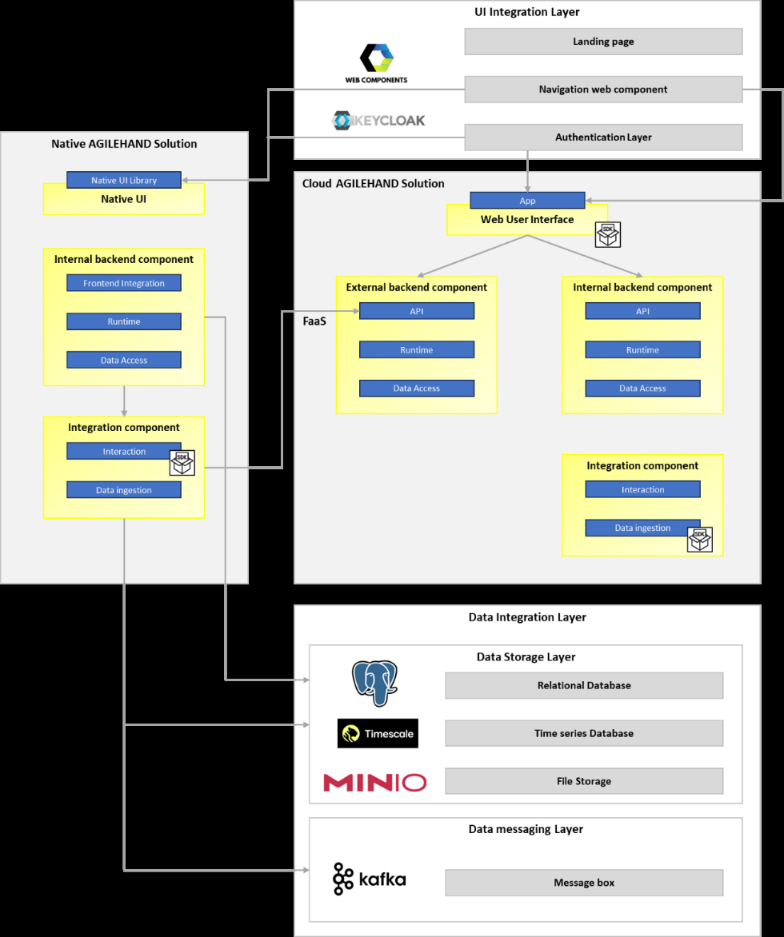
Figure 1: The AGILEHAND solutions architecture.

3.1. Native and Cloud AGILEHAND Solution
The architecture of the solutions is characterized by modularity and seamless integration, catering not only to cloud-based and on-premises systems but also incorporating native components such as PC desktop applications. This comprehensive approach ensures robust and versatile functionality across various platforms. In particular, the emphasis is on delineating specific layers, each assigned distinct roles within the overall framework:
- UI Components: Encompassing all user-facing elements of the solutions, these components ensure a unified and consistent user experience across diverse solutions. This uniformity extends to the look and feel, behaviour, and overall usability of the interfaces, including those on native PC desktop applications. Such integration allows for a cohesive experience, whether the user is interacting with cloud-based interfaces or on-prem desktop applications. Furthermore, it must be ensured that the different functions and information of the individual solutions are provided to the user correctly and comprehensibly.
- Internal Backend Components: Handling critical aspects such as business logic, data processing, and decision-making algorithms. Internal Backend Components operate behind the scenes, not directly exposed to external interfaces but indispensable for the solutions' functionality. These components seamlessly interact with the Data Integration layer to retrieve essential data, whether residing on-premises or in the cloud, ensuring comprehensive data management and processing. These Internal Backend Components are developed individually and specifically for the specific AGILEHAND solutions.
- External Backend Components: These components serve as the gateway for external systems or solutions to interface with the solution through well-defined APIs, providing a standardized means of interaction and data exchange. This includes connections to both cloud-based services and on-premises systems, allowing for a flexible and scalable architecture that can adapt to different deployment environments.
To integrate these components, APIs (Application Programming Interfaces) and web services enable secure communication and data exchange. For instance, a native app on a smartphone might use APIs to interact with both the On-Premises ERP system and the cloud-hosted CRM system. Ensuring security and compliance is crucial across different environments, especially when handling sensitive data. This includes secure authentication, encryption, and adherence to data protection regulations.
Data management and analytics play a significant role, with data collected from native apps being stored and processed either On-Premise or in the Cloud. Cloud-based analytics platforms can be utilized for advanced data analysis and business intelligence. Many organizations employ a combination of on-premises and multiple cloud services (multi-cloud) or hybrid cloud solutions to optimize their IT infrastructure. This architecture enables organizations to leverage the high performance of native applications, the control and security of On-Premise systems, and the scalability and flexibility of cloud services.

3.2. UI integration layer
The UI Integration layer must be purposefully designed to act as the central nexus, seamlessly facilitating user interactions across the spectrum of AGILEHAND solutions. With careful attention to detail and precision, this hub stands out as a sophisticated orchestrator, unifying and streamlining the user experience throughout AGILEHAND's diverse solution landscape. At its core, this layer comprises essential components that play pivotal roles in enhancing connectivity and coherence across the AGILEHAND ecosystem, such as.
- Landing Page: Serving as a universal entry point with various interfaces. Firstly, it may feature access to static documentation about AGILEHAND, offering valuable information.
- Navigation Web Component: This dynamic component operates as a navigational powerhouse, furnishing links to user interfaces within different cloud-based solutions. It functions as a menu button or navigation bar tailored to the user's permissions and roles. This strategic design enables users to seamlessly access multiple solutions without the inconvenience of repeated logins or disjointed interfaces.
- Single-Sign-On: Integrated into the system for authentication, a system such as Keycloak facilitates Single-Sign-On. This not only streamlines the user experience but also bolsters security by centralizing user authentication and authorization. Such a system boasts capabilities in user identity management, federation with other identity providers, and customization for various protocols like OpenID Connect or SAML, adding a layer of versatility to its functionality.

3.3. Data Integration Layer
The Data Integration Layer stands as the cornerstone for comprehensive data management across the entirety of AGILEHAND solutions. Tailored to adeptly handle diverse data types, it offers indispensable services that encompass data persistence, retrieval, and real-time processing. This layer functions as a centralized data hub, orchestrating all interactions related to data within AGILEHAND. By consolidating data operations in this strategic layer, we not only ensure and enhance the consistency, availability, and integrity of data but also address critical aspects such as security, scalability, and overall system performance.
This integral component permits a standardized and streamlined approach to data management, significantly simplifying development, integration, and maintenance processes. Through the centralization of data services, it becomes more straightforward to uphold high availability, adhere to security and regulatory requirements, and ensure efficient recovery mechanisms, making it an essential element for the seamless functioning of the integrated AGILEHAND ecosystem. In particular, the Data Integration Layer is further categorized into specific services providing several database services meticulously adapted to the distinct data requirements of various AGILEHAND solutions. This multi-database strategy empowers each solution to choose the most fitting storage mechanism for its unique data needs. Data services within this layer encompass:
- Relational Databases (e.g., PostgreSQL [9]): Engineered to manage structured data with defined relationships, relational databases utilize a schema to articulate tables, fields, and their interconnections.
- Time-Series Databases (e.g., Timescale [10]): Optimized for time-series data, where data points are indexed chronologically.
- File Storage Services (e.g., MinIO [11]): Serving as a high-performance distributed object storage system designed for extensive data storage.

4. Discussion and Conclusion
This paper has presented a comprehensive overview of the digital solution architecture developed for the AGILEHAND European project. The exploration has revealed a multifaceted architecture that successfully integrates diverse technologies and platforms, aligning with Europe's broader digital strategy and innovation goals.
Several key components have been identified that form the backbone of this architecture, including advanced cloud-based services, robust On-Premise systems, and sophisticated data management and analytics tools. The integration of these components was a critical factor in the architecture's overall effectiveness, providing a balance between scalability, security, and functionality.
Throughout the project, numerous challenges have been faced and overcame, notably in areas of data privacy and regulatory compliance, which are particularly pertinent given the stringent EU regulations. The proposed solutions to these challenges have not only enhanced the project but also provided valuable insights for similar future endeavours.
A notable aspect of the AGILEHAND architecture is its adaptability and scalability. It is designed to evolve in response to the rapidly changing digital landscape, ensuring long-term relevance and utility. Furthermore, the architecture's modular nature allows for flexibility in adoption across various sectors and scalability to different project sizes, making it a versatile model for future European digital initiatives.
In comparing our architecture with existing models, several advancements can be highlighted, particularly in the realms of interoperability and user-centric design. These enhancements position our architecture as a forward-thinking model, potentially influencing the direction of future digital solution architectures in Europe.
In conclusion, the digital solution architecture developed in this project stands as a testament to collaborative innovation, technical excellence, and strategic foresight. It not only addresses the immediate needs of the project but also sets a benchmark for future digital initiatives across Europe, contributing to the continent's ongoing digital transformation journey.

Acknowledgements
This paper is supported by European Union's Horizon Europe research and innovation programme under grant agreement No 101092043, project AGILEHAND (Smart Grading, Handling and Packaging Solutions for Soft and Deformable Products in Agile and Reconfigurable Lines).

Declaration on Generative AI
The author(s) have not employed any Generative AI tools.

References
[1] H. M. F. Shehzad, R. B. Ibrahim, A. F. Yusof, K. A. M. Khaidzir, M. Iqbal and S. Razzaq, “The role of interoperability dimensions in building information modelling,” Computers in Industry, vol. 129, no. 103444, 2021.
[2] A. Campmas, N. Iacob and F. Simonelli, “How can interoperability stimulate the use of digital public services? An analysis of national interoperability frameworks and e-Government in the European Union,” Data & Policy, vol. 4, no. e19, 2022.
[3] L. Coppolino, R. Nardone, A. Petruolo, L. Romano and A. Souvent, “Exploiting Digital Twin technology for Cybersecurity Monitoring in Smart Grids,” in ARES ’23: Proceedings of the 18th International Conference on Availability, Reliability and Security, 2023.
[4] V. Margariti, T. Stamati, D. Anagnostopoulos, M. Nikolaidou and A. Papastilianou, “A holistic model for assessing organizational interoperability in public administration,” Government Information Quarterly, vol. 39(3), no. 101712, 2022.
[5] C. Ramonell, R. Chacón and H. Posada, “Knowledge graph-based data integration system for digital twins of built assets,” Automation in Construction, vol. 156, no. 105109, 2023.
[6] A. J. Bokolo, “Applying Enterprise Architecture for Digital Transformation of Electro Mobility towards Sustainable Transportation,” in SIGMIS-CPR’20: Proceedings of the 2020 on Computers and People Research Conference, 2020.
[7] A. Kouroubali and D. G. Katehakis, “The new European interoperability framework as a facilitator of digital transformation for citizen empowerment,” Journal of Biomedical Informatics, vol. 94, no. 103166, 2019.
[8] M. Fischer, F. Imgrund, C. Janiesch and A. Winkelmann, “Strategy archetypes for digital transformation: Defining meta objectives using business process management,” Information & Management, vol. 57(5), no. 103262, 2020.
[9] T. P. G. D. Group, “PostgreSQL,” 2023. Available: https://www.postgresql.org/docs/. Last access: 1-2-2024.
[10] T. Inc., “Timescale,” 2024. Available: https://docs.timescale.com/. Last access: 1-2-2024.
[11] I. MinIO, “MinIO,” 2023. Available: https://min.io/. Last access: 1-2-2024.

